1. Hosting Static Website on Amazon S3
(AWS S3 is best for static HTML/CSS/JS websites, no backend logic.)
Step 1: Create an S3 Bucket
- Go to AWS Console → S3 → Create bucket.
- Bucket name must be globally unique (e.g., mywebsite-demo).
- Choose region close to your users.
Step 2: Upload Website Files
- Upload your HTML, CSS, JS, images, etc.
- Keep your entry file named index.html.
Step 3: Enable Static Website Hosting
- In your bucket → Properties → "Static website hosting".
- Enable it, set index document to index.html.
- Copy the website endpoint given.
Step 4: Set Permissions (Public Access)
- Go to Permissions → Uncheck “Block all public access”.
- Add a bucket policy like:
{
"Version": "2012-10-17",
"Statement": [
{
"Effect": "Allow",
"Principal": "*",
"Action": "s3:GetObject",
"Resource": "arn:aws:s3:::mywebsite-demo/*"
}
]
}

2. Hosting Static Website on Amazon EC2
(EC2 gives you a VM where you install a web server like Apache or Nginx.)
Step 1: Launch EC2 Instance
- Go to EC2 → Launch Instance.
- Choose Amazon Linux 2 (or Ubuntu).
- Select instance type (t2.micro for free tier).
- Configure → Create new key pair (for SSH).
- Launch.
Step 2: Connect to Instance
- Use SSH from your terminal:
ssh -i my-key.pem ec2-user@<EC2-Public-IP>
Step 3: Install Web Server
For Amazon Linux:
sudo yum update -y
sudo yum install -y httpd
sudo systemctl start httpd
sudo systemctl enable httpd
For Ubuntu:
sudo apt update
sudo apt install -y apache2
sudo systemctl start apache2
sudo systemctl enable apache2
Step 4: Upload Website Files
- Copy files via scp:
scp -i my-key.pem index.html ec2-user@<EC2-Public-IP>:/var/www/html/
- Place all HTML/CSS/JS files in /var/www/html/.
Step 5: Security Group Rules
- In EC2 → Security Groups → Inbound Rules.
- Add rule: HTTP → Port 80 → Source: Anywhere (0.0.0.0/0).
Step 6: Access Website
- Open http://<EC2-Public-IP> in browser.

SQL
1. Launch EC2 Instance
- Open AWS Console → EC2 → Launch Instance.
- Choose Amazon Linux 2 AMI (Free Tier Eligible).
- Select t2.micro (Free Tier).
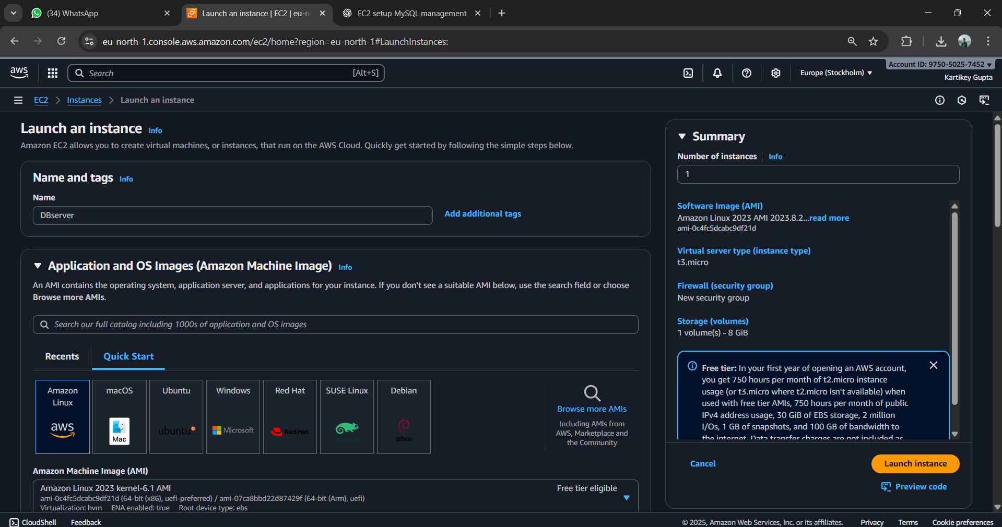
- Create/download a Key Pair (.pem) (needed for SSH).
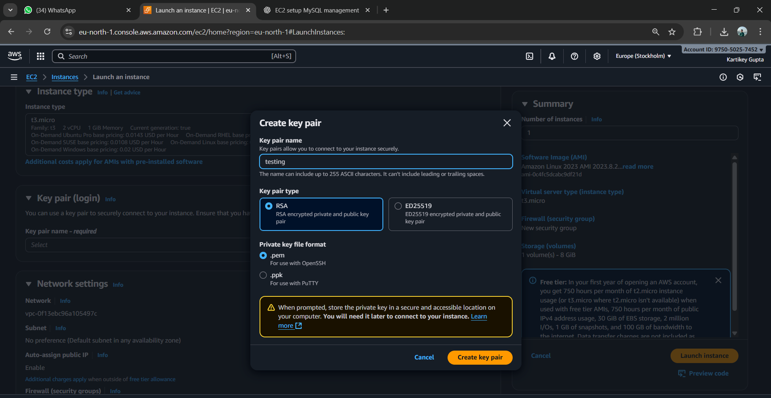
- Security Group → Add rules:
  - SSH (22) → My IP only
  - MySQL (3306) → (only if you need remote DB access, otherwise skip).
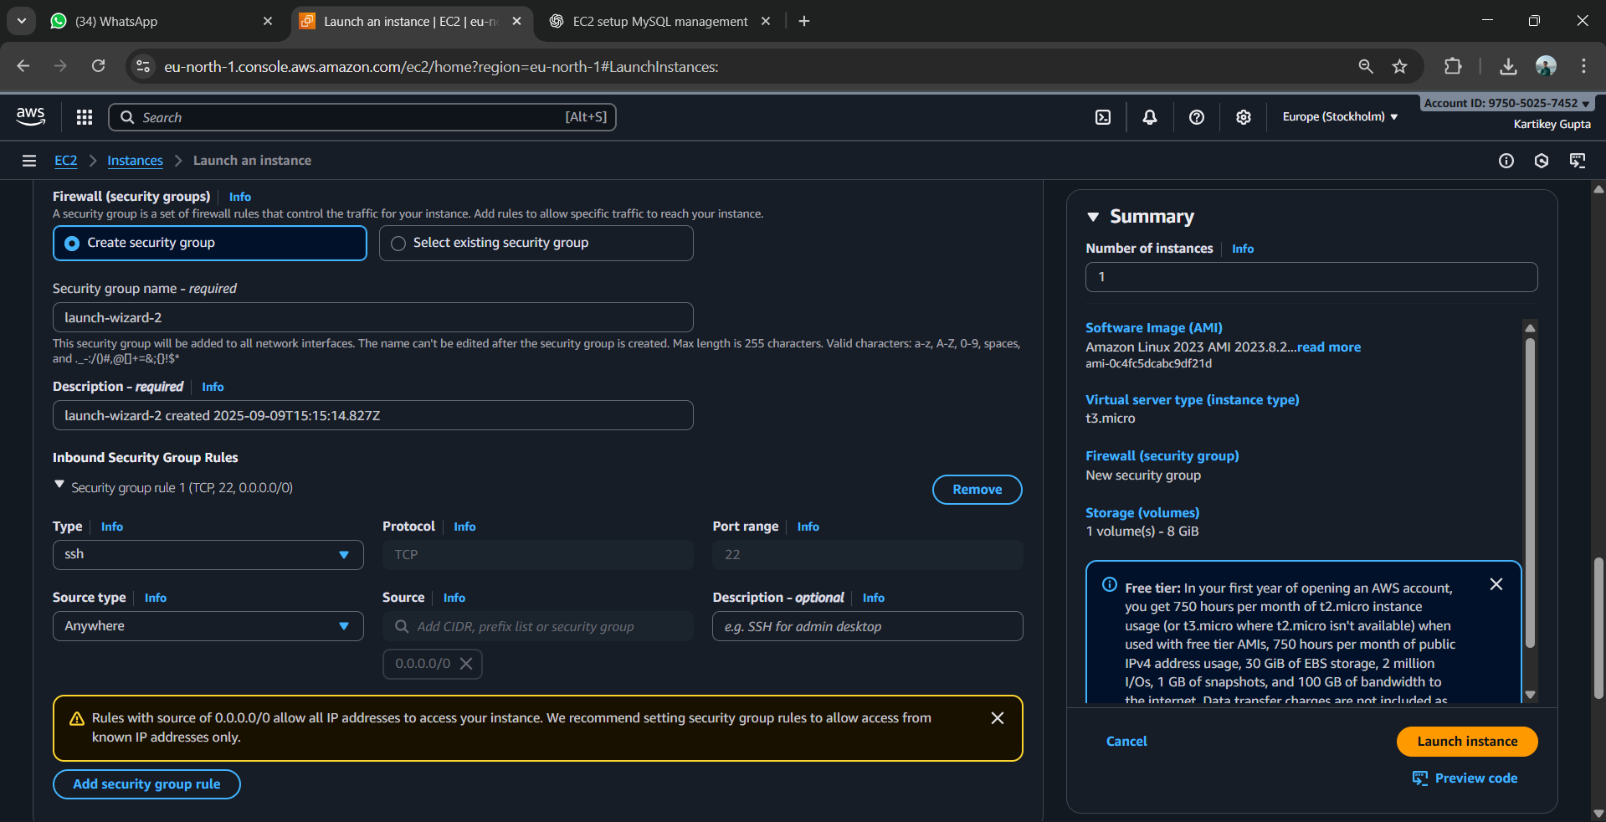
- Click Launch Instance.

2. Connect to EC2
- Download the .pem key (from step 4).
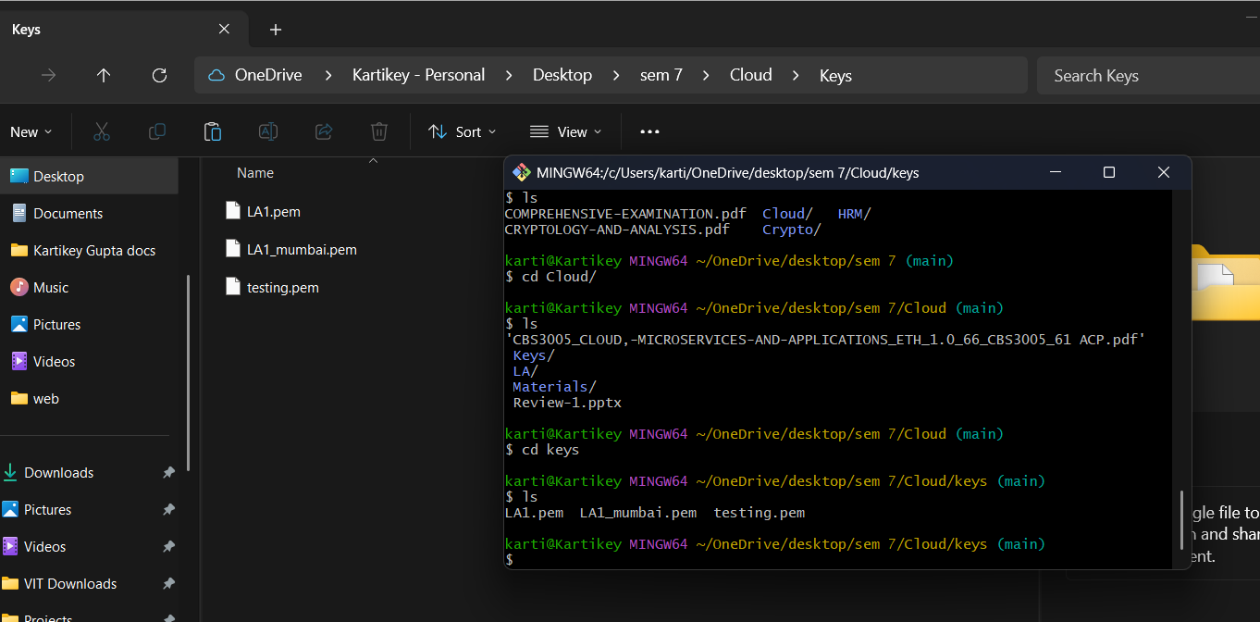
- In your terminal:
- chmod 400 key.pem
- ssh -i key.pem ec2-user@<EC2-Public-IP>
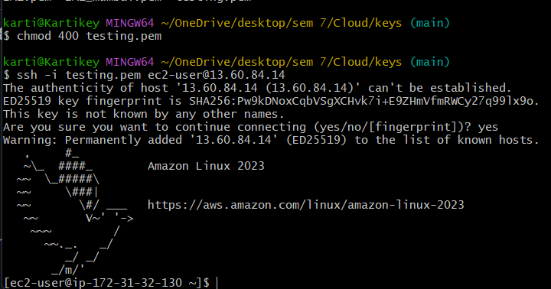
(Replace <EC2-Public-IP> with your instance’s public IP).

3. Install MySQL (MariaDB)
Installing MySql
- sudo dnf update -y
- sudo dnf install mariadb105-server -y
Start and enable MySQL:
- sudo systemctl start mariadb
- sudo systemctl enable mariadb

Log in to MySQL CLI
sudo mysql -u root -p
CREATE DATABASE student;
USE student;
CREATE TABLE students (
id INT AUTO_INCREMENT PRIMARY KEY,
name VARCHAR(50),
age INT
);
INSERT INTO students (name, age) VALUES ('Aman', 20), ('Priya', 21), ('Ravi', 22);
SELECT * FROM students;

Elastic Beanstalk
Step 2: Log in to AWS Management Console
- Go to AWS Console.
- Log in with your AWS account.
- Navigate to Elastic Beanstalk
Step 3: Create a New Application
- Click Create application.
- Enter Application name: La2JavaApp.
- Add an optional description: Sample Spring Boot app.
- Click Create application
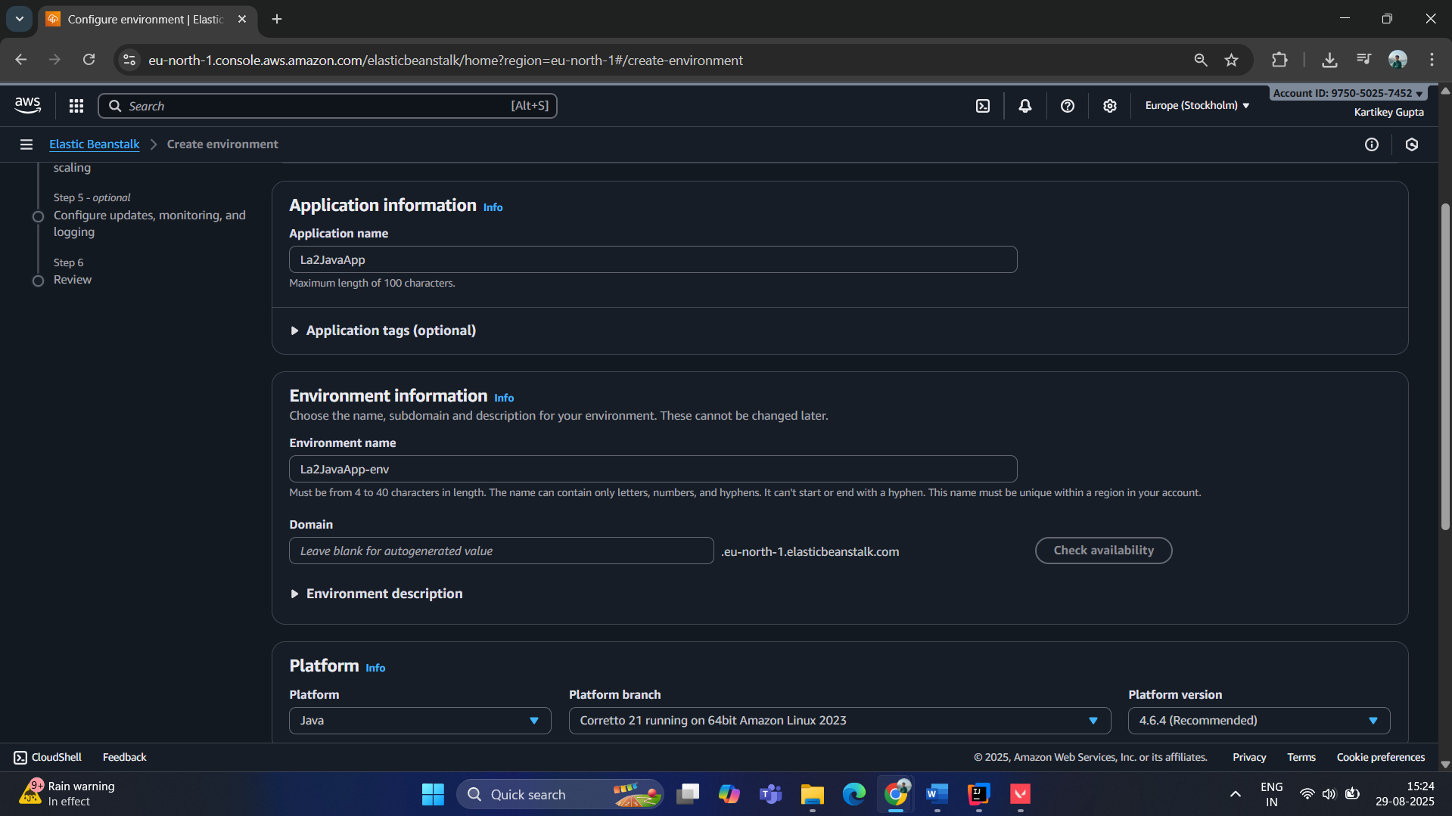
Step 5: Configure Environment and Platform
- Environment name: La2JavaApp-env
- Platform: Choose Java
  - For Spring Boot JAR: choose Corretto 17 (or latest Java 17+)
- Platform branch: Keep the default
Step 6: Upload Your Application
- Under Application code, choose Upload your code.
- Click Choose file and select your JAR file from target/.
Step 7: Optional Environment Settings
- Instance type: For testing, choose t2.micro (free tier eligible).
- Capacity: Keep single instance.
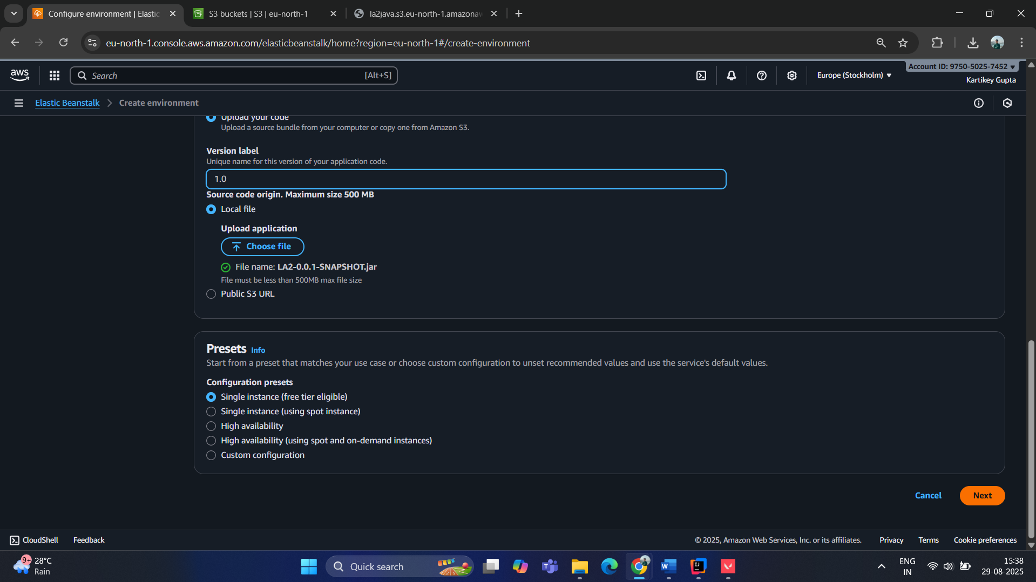

Uploading JAR file:
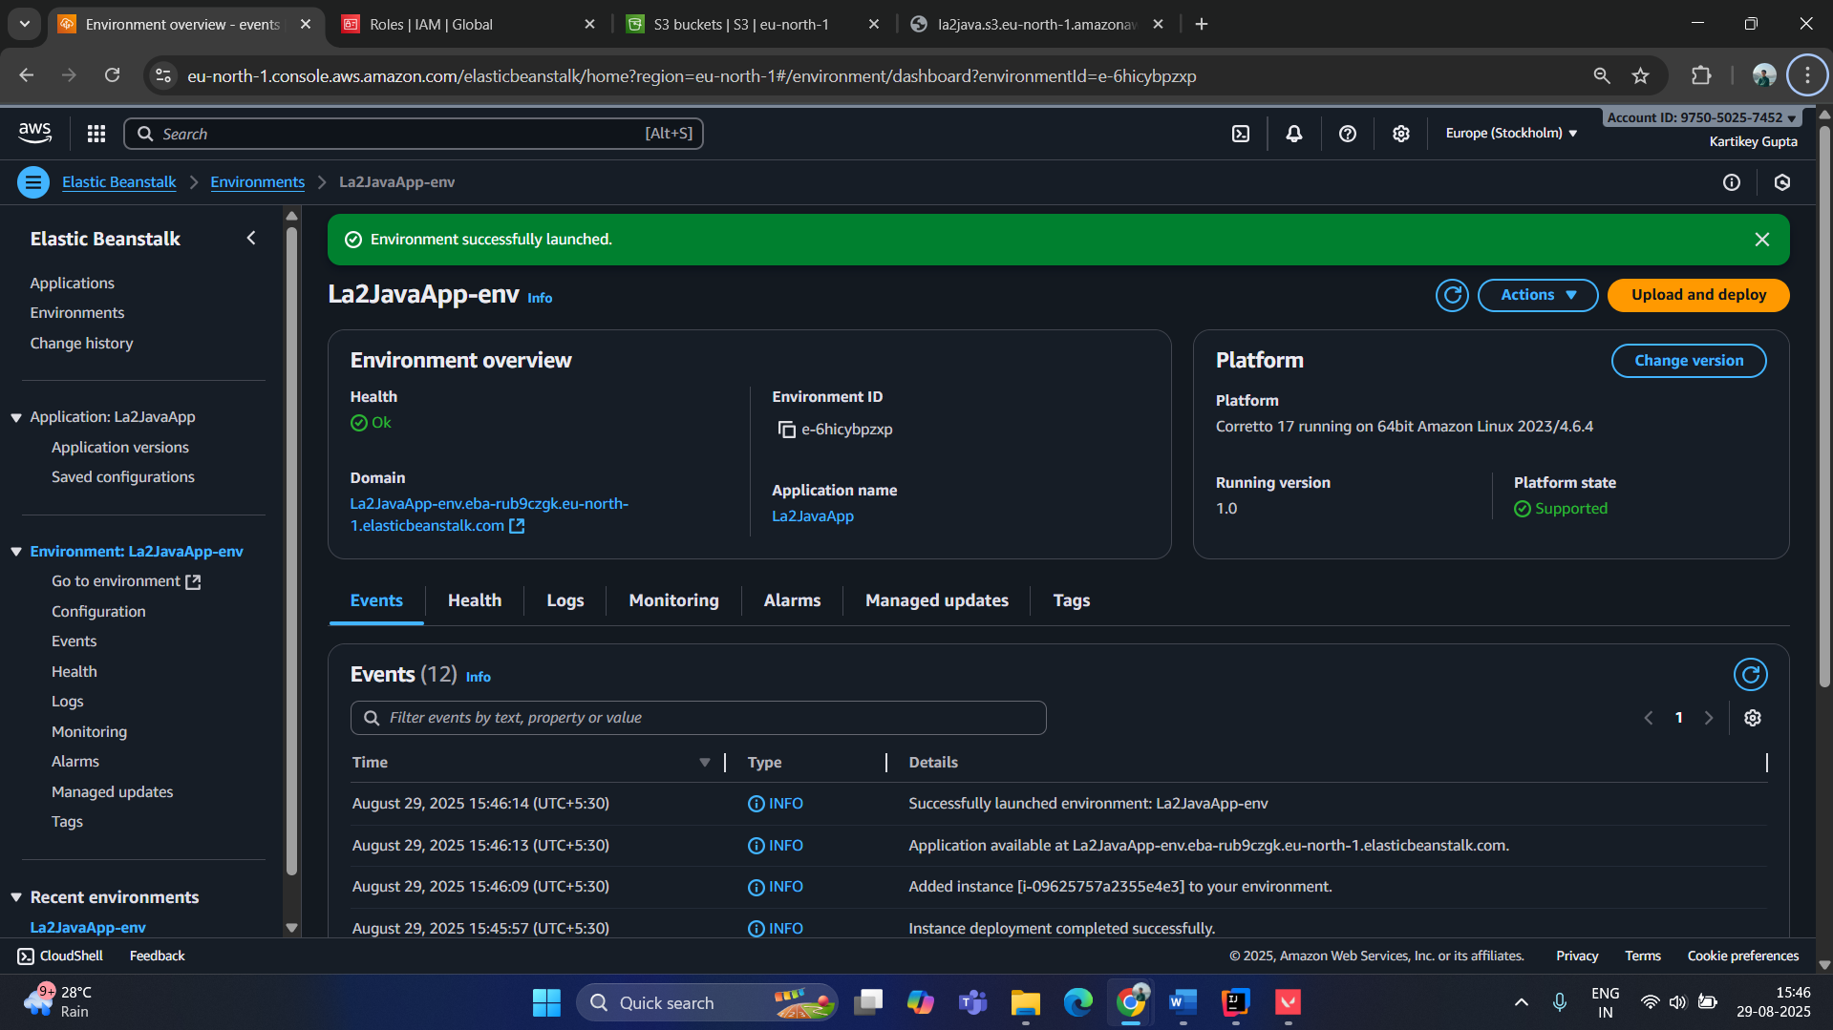
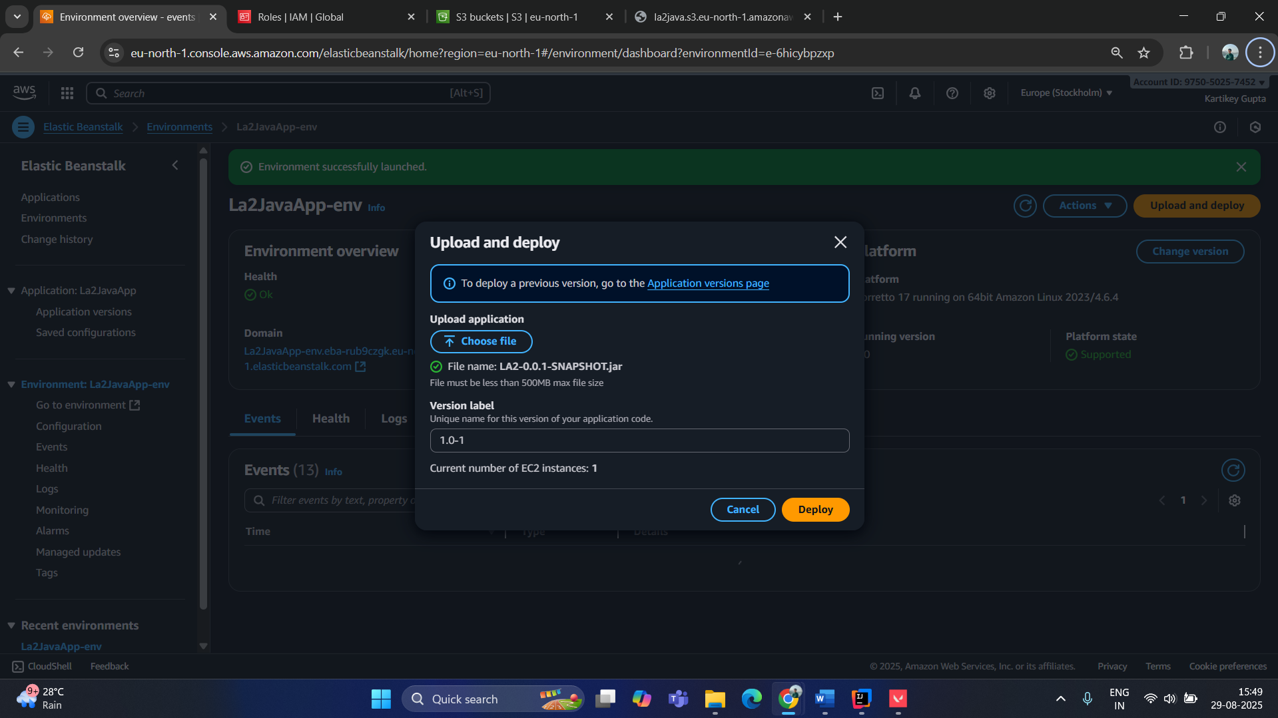

Lambda Python:
import json
import urllib.parse
import boto3

print('Loading function')

s3 = boto3.client('s3')

def lambda_handler(event, context):
# Uncomment for debugging
# print("Received event: " + json.dumps(event, indent=2))

# Get the object from the event
bucket = event['Records'][0]['s3']['bucket']['name']
key = urllib.parse.unquote_plus(event['Records'][0]['s3']['object']['key'], encoding='utf-8')

try:
response = s3.get_object(Bucket=bucket, Key=key)
print("CONTENT TYPE: " + response['ContentType'])
return response['ContentType']
except Exception as e:
print(e)
print('Error getting object {} from bucket {}. Make sure they exist and your bucket is in the same region as this function.'.format(key, bucket))
raise e

